Project Report On

**TailorTape Web App**



403L-Database Management Systems

Department of Computer System Engineering

University of Engineering and Technology Peshawar

Submitted to: **Mam Summayyea Salahuddin**

Submitted by:

**Muhammad Umar Jan 21PWCSE2000 Sec: B**

**Muhammad Saad 21PWCSE1997 Sec: B**

**Hamza 21PWCSE1990 Sec: A**

Date: **Tue, June 25, 2024**

**Project Title TailorTape**

TailorTape is a mobile application developed using Flutter, designed to enhance the workflow of tailors and improve the customer experience. The application provides separate accounts for tailors and customers, allowing tailors to manage customer measurements and orders, while customers can view their order history and communicate with their tailor. This report outlines the development process, features, technical specifications, timeline, and budget of the TailorTape project.

**Project Objectives**

1. **Efficiency**: Streamline the management of customer measurements and orders for tailors.

2. **Customer Experience**: Provide an intuitive interface for customers to interact with their tailor and track their orders.

3. **Customization:** Enable customers to select cloth colors for each order to ensure personalized service.

**Features**

**Tailor Account**

1. **Customer Management**

- **Add New Customers:** Tailors can record measurements and personal information for new customers.

- **Delete Customers**: Tailors can remove customers from the database.

- **Edit Customer Details**: Tailors can update measurements and personal information.

2. **Order Management**

* **Add Orders**: Tailors can create new orders for customers, including measurements, cloth color, and special instructions.
* **Order Tracking**: Tailors can monitor the status of each order.

3. **Measurement Recording**

* **Standard Measurements**: Predefined fields for common measurements.
* **Custom Measurements**: Option to add custom measurement fields.

4. **Cloth Color Selection**

* **Color Palette**: Tailors can provide a range of cloth colors.
* **Custom Colors**: Option to add custom colors based on customer preferences.

**Customer Account**

1. **Profile Management**

* **View and Edit Profile**: Customers can view and update their personal information.

2. **Order History**

* **View Orders**: Customers can view details of past and current orders.
* **Order Status Tracking**: Real-time updates on the status of orders.

3. **Cloth Color Selection**

* Browse Colors: Customers can select cloth colors for their orders.

4. **Communication**

* **Messaging**: In-app messaging for customers to communicate with their tailor.

**Technical Specifications**

* **Framework**: Flutter for cross-platform compatibility (iOS and Android).
* **Backend**: Firebase for real-time database and authentication.
* **State Management**: Provider or Riverpod for managing state within the app.
* User Interface: Material Design principles for a clean and intuitive interface.
* **Authentication**: Email/Password and Social Media (Google, Facebook) login options.

**Challenges and Solutions**

1. **Real-time Data Sync**: Ensuring real-time synchronization of data across devices was challenging. This was addressed using Firebase’s real-time database capabilities.

2. **User Interface Design**: Creating an intuitive and user-friendly interface required multiple iterations and user feedback.

3. **Cross-platform Compatibility**: Ensuring the app worked seamlessly on both iOS and Android required rigorous testing and adjustments.

Firebase Database:

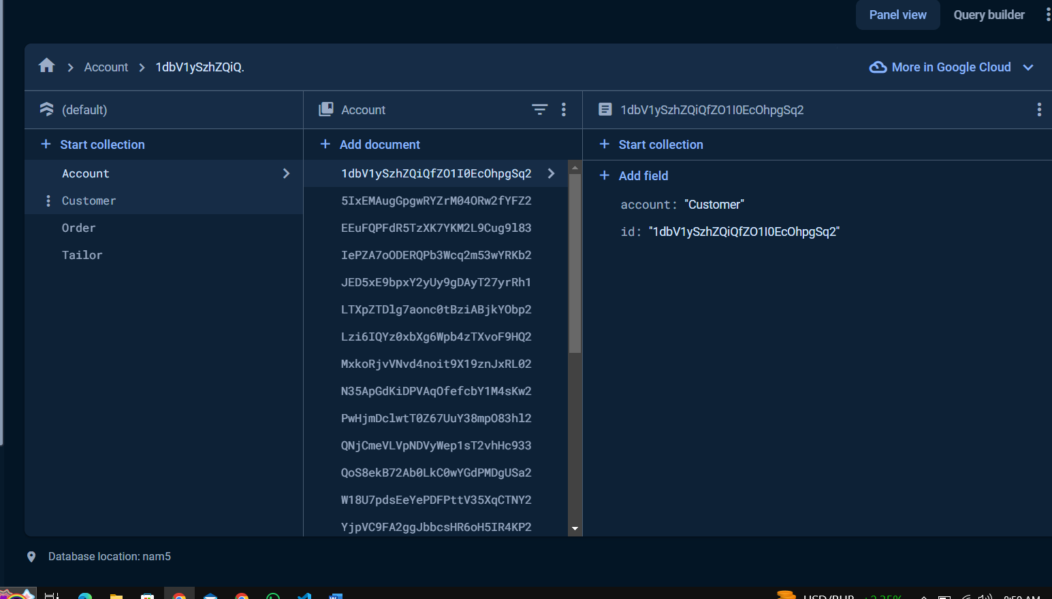

Order

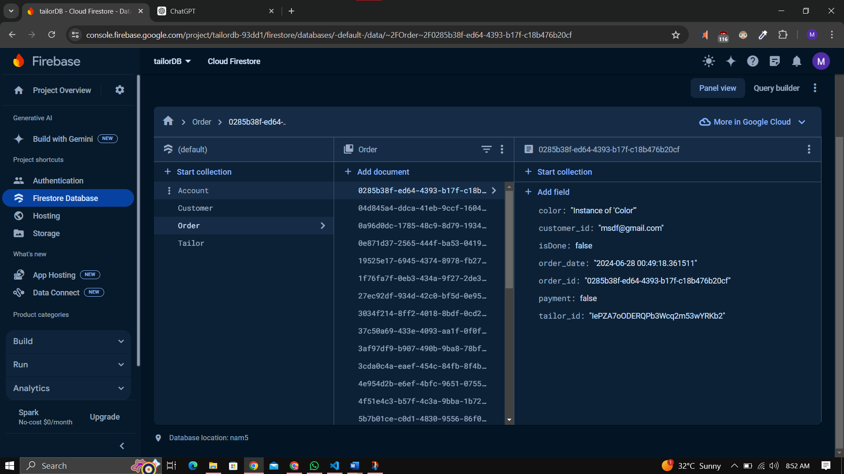

**Conclusion**

The TailorTape project successfully met its objectives, providing a comprehensive and user-friendly mobile application for tailors and customers. The app streamlines the management of customer measurements and orders, enhances the customer experience, and offers customization options for cloth colors. With a clear development process, robust technical implementation, and a dedicated budget, TailorTape is poised to revolutionize the tailoring business.